CSC20 HW#4 TopTen Song List Sp2020

You will implement methods of a program that maintains the top ten songs in a list. The program reads the song titles from a file called *Songs.txt* (given) and stores them in a Linked List data structure. Each *List Node* (given in *LinkNode.java*) stores the title of the song *(String*) and its position (*int*) in the chart. The user can update this list by deleting, inserting, moving, finding and determining the chart position of a song. At any given time, only *a maximum* of ten songs can be stored.

The program is menu driven and has the following options and capabilities:

* P - print the top ten chart //given and implemented
* I - insert a new song at a given position // your task to implement o D - remove a song from the chart // your task
* M - move a song to a higher or lower position in the chart. //your task o S - get song title //given o N - get song position // given o Q - exit the program // given



chart and repeatedly offers these menu options until the user chooses to exit. Thesefeatures are implemented as instance methods of the *TopTen class* in tfile*TopTen.java.* The supplementary file *ChartHelper.java* contains static methods used by the driver. The driver program contains the menu and implements the print, get title, get position and exit options. All helper methods and supporting methods are provided.

So you are given the following files: *LinkNode.java, TopTen.java, TopTenMain.java, ChartHelper.java and Songs.txt.* You need to make changes in *TopTen.java* only and implement the **deleteSong**, **insertSong** and **moveSong** methods in the commented area

The print option displays the chart:

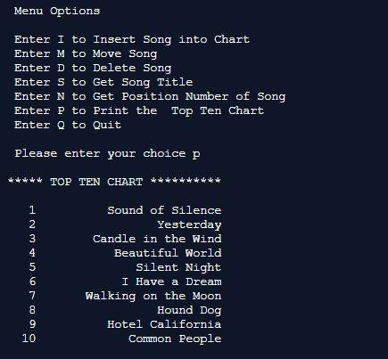

#You need to implement the following instance methods in *TopTen.java*:

1. boolean deleteSong(int position)

// deletes a song in the given position and updates the chart with the new position for all the songs remaining in the chart

A typical delete operation should look like this:

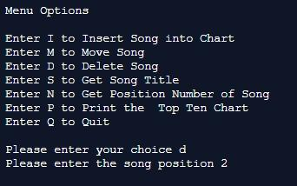

Now the song at position 2 is deleted and the list will print as follows:

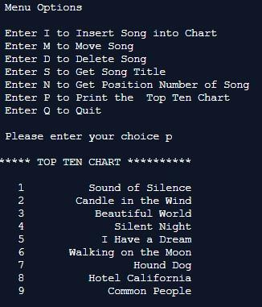

# Insert a song at a given position

|  |  |
| --- | --- |
| boolean insertSong(int position,String song) | |
| // inserts a new song at the given position and adjusts the remaining list. |  |
| **If the size exceeds ten, the last song falls off the chart.** | |

2.

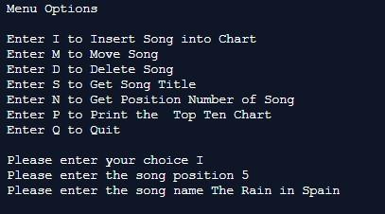

The chart now looks like this:

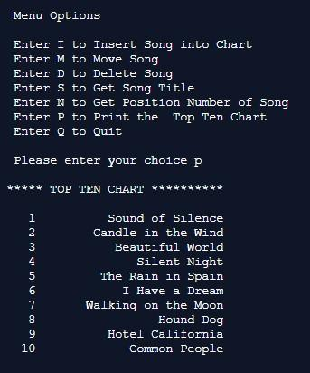

# Move a song to a new position

3. boolean moveSong(int oldPosition, int newPosition)

// moves a song either up or down in the chart and adjusts position numbers of this and all other songs accordingly.

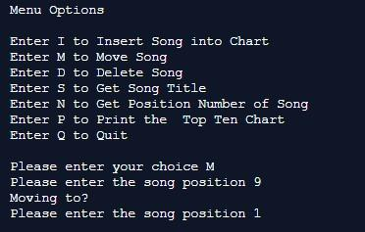

The updated chart is now:

